Name _______________________________ AP Calculus
Review: Sections 4.1 – 4.4

Show all your work! Allowed to use a calculator with any problem with an “*”

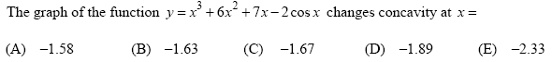
*1.

2.

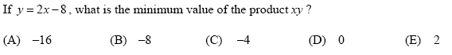
3.

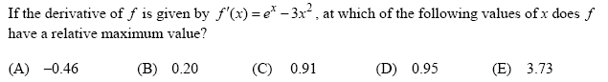
*4.

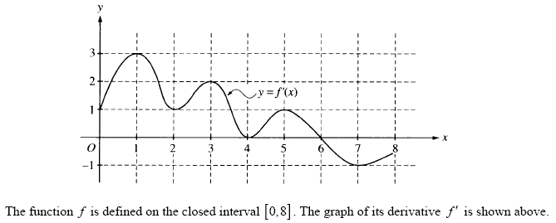
5.

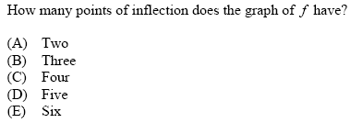

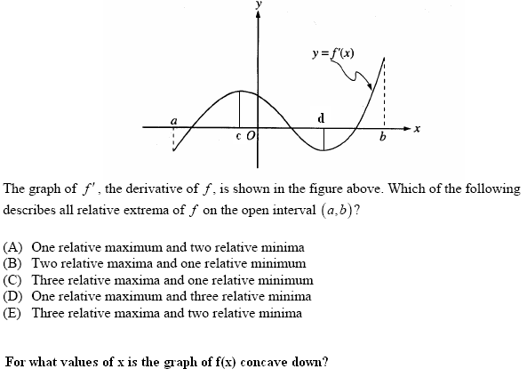
6 – 7.

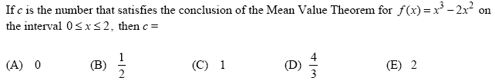
8.

9. A particle moves along a line with position x(t) = 2t³ -10t² + 14t – 11, t ≥ 0. During which
interval(s) is the particle moving to the left?

